**Project Design Phase-II**

**Data Flow Diagram &User Stories**

|  |  |
| --- | --- |
| Date | 17 October 2022 |
| Team ID | PNT2022TMID31901 |
| Project Name | Project – Estimate the crop yield using data analytics |
| Maximum Marks | 4 Marks |

DFD Level 0 (Industry Standard)

**Data Flow Diagrams:**

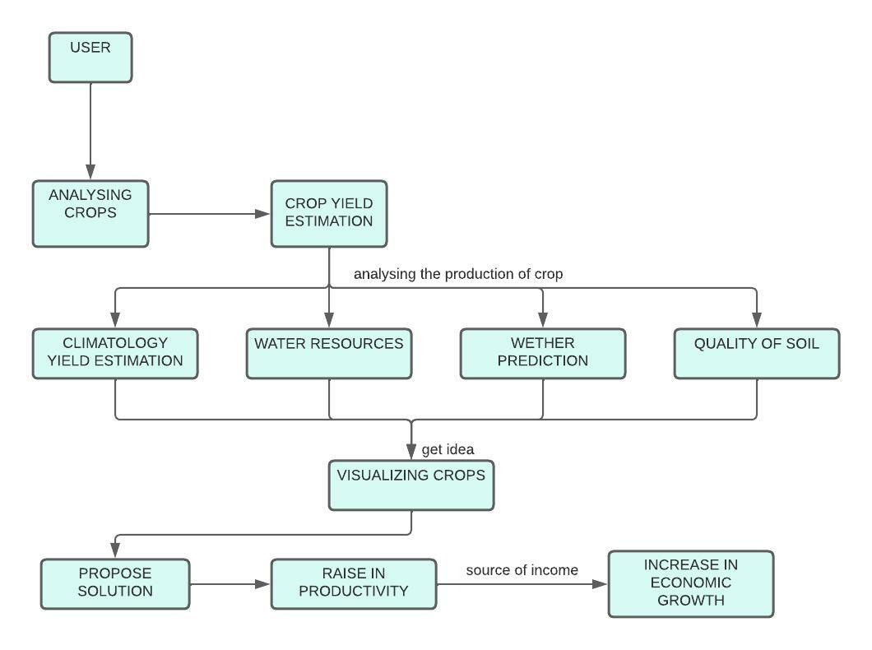

**User Stories:**

| **User Type** | **Functional Requirement (Epic)** | **User Story Number** | **User Story / Task** | **Acceptance criteria** | **Priority** | **Release** |
| --- | --- | --- | --- | --- | --- | --- |
| Customer (Mobile user) | Registration | USN-1 | As a user, I can register for the application by entering my email, password, and confirming my password. | I can access my account / dashboard. | High | Sprint-1 |
|  |  | USN-2 | As a user, I will receive confirmation email once I have registered for the application. | I can receive confirmation email & click confirm. | High | Sprint-1 |
|  |  | USN-3 | As a user, I can register for the application through WhatsApp , Facebook. | I can register & access the dashboard with WhatsApp , Facebook Login. | Low | Sprint-1 |
| Customer (Web user) | Registration | USN-4 | As a user, I can register for the application by entering my email, password, and confirming my password. | I can access account / dashboard. | High | Sprint-1 |
|  | Required Data |  | Cropping history , profit and loss in their farming. | Past dataset of cropping and field estimation of crop yield. | High | Sprint-2 |
|  | Analysis |  | Clean and analyse the data according to the set past data. |  | High | Sprint-3 |
| Customer Care Executive | Communication |  | As a user , I can provide support systems for  companies that often communicate with the customers. | I can maintain strong relationship with customer and client , so I can ease their queries and increase productivity. | Medium | Sprint-4 |
| Estimator | Estimation |  | As a user, I can go through all the items and will try to estimate this session. | I have a feel for the size of the various items in the product based. | Medium | Sprint-4 |